1. What year did the Umayyad Dynasty take power? ________

2. During Hajj, what do pilgrims share? 1. ___________________ and 2. _______________

3. By 710, the Umayyads controlled the whole of _____________________ from the _________
River to the _______________ Ocean.

4. Which group opposed (or didn’t agree with) the Umayyads? _________________

5. What does bureaucracy mean? ______________________________________________________

6. Where would I find the Iberian Peninsula? _____________________________________________

7. How far EAST did the Umayyad Dynasty extend to? _____________________

8. How did the Umayyad armies gain control over such cities as Bukhara and Samarkand?
______________________________

9. What city is the Umayyad capital? ____________________

10. Which caliph declared Arabic the language of government for all Muslim lands? ______________

11. What group of people were able to stopped Muslim advancement further into Europe?
_______________

12. What three things helped unite the Muslims under Umayyad rule? 1. ______________________
2. __________________________ 3. _______________________

13. How far WEST did the Umayyad Dynasty extend to? ______________________

14. What happened when the Abbasids invited the Umayyads over for dinner? __________________

15. By the early 700s, the Umayyads had taken control of much of ______________________.

16. Some Muslims accused the Umayyads of being too interested in living a ____________________
and holding on to ____________.

17. What year was the Battle of Tours fought? _________

18. What helped bring about the blending of many different cultures? ______________________

19. Which Umayyad person escaped the Abbasid ambush? ____________________

20. What are Muslim governors called? _________

Directions: Complete the chart below by writing the correct sentence in the appropriate box.

- Established a bureaucracy that ruled from Damascus.
- Some Muslims felt the Umayyads were too interested luxury.
- Their appointment helped the Umayyads gain widespread local support.
- In the east, extended control from Persia north into Central Asia and east to the Indus River valley.
- Common coinage aided commerce and helped spread Islam.
- The caliphs appointed governors called emirs to rule different provinces.
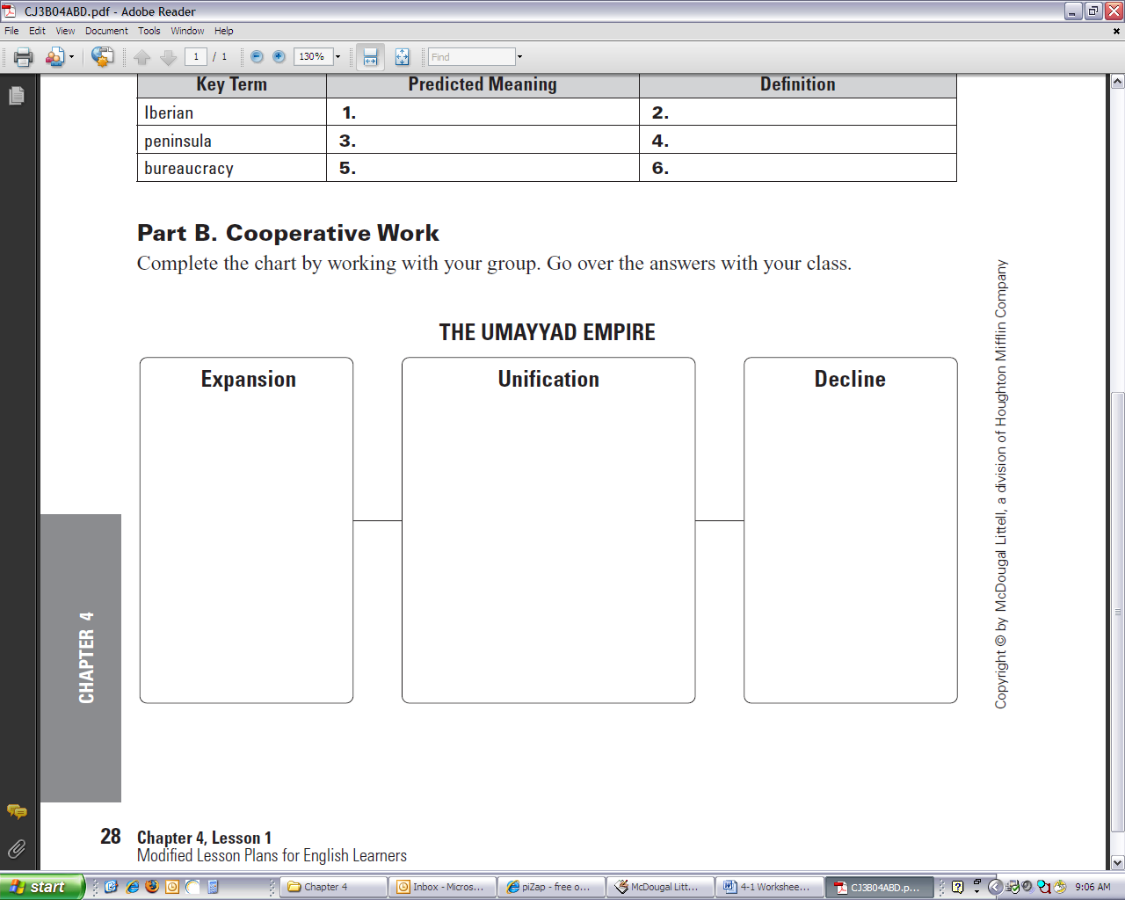
- One Umayyad leader fled to Spain, where he reestablished the Umayyad dynasty on the Iberian Peninsula.
- Declared Arabic the language of government for the empire.
- Umayyads came to power in 661.
- Encouraged people to make pilgrimages to Mecca, where they met Muslims from other parts of the empire, which led to cultural sharing.
- Umayyads overthrown by force or by treachery by the Abbasids.
- The emirs were often local clan leaders.
- They were unable to expand into France.
- Introduced a common coinage that included Arabic sayings from the Qur’an.
- In the west, extended control across northern Africa and throughout most of the Iberian Peninsula.

